

Drought Proofing Agri-Catchments

Project report

**Draft (May 2021)**

**International Water Management Institute**

**New Delhi**

Contents

1. Drought: Concept, definition and types 3

2.1 Drought types 3

2.2 Drought assessment and declaration 5

2. Drought proofing ITC catchments: IWMI-ITC Knowledge Partnership 7

3. Defining ‘Drought Proofing’ 8

4. Classification of drought vulnerability 9

4.1 Standard Precipitation Index (SPI) 9

4.2 Hydrology drought: Groundwater and surface water drought index 11

5. Conceptual drought proofing framework and indicators 11

5.1 Drought proofing indicators 13

6. Water Balance tool for operationalising framework 15

6.1 Methodology 15

Management processes 16

Water management practices 18

7. Working of Water balance tool 23

7.1 Step 1: Input Parameters 24

7.2 Step 2: Scenario Setup & Selection of Interventions 25

7.3 Step 3: Output 26

Water Balance Results 26

Water Productivity 26

Yield, CWR & Production 27

Economic analysis 27

References 28

# Background and Scope of the IWMI-ITC Knowledge Partnership

ITC’s Social Investments Program, “Mission Sunehra Kal” aims to address the vulnerabilities of agricultural communities, particularly with respect to water. The focus of the mission is on assisting communities to collectively conserve and manage local natural resources, broad-base farming systems and expand off-farm income portfolios to promote the growth of rural economies. Community participation and multi-stakeholder partnerships are intrinsic to the model. ITC’s integrated watershed development projects already cover more than 300,000 ha in 14 states across India. ITC plans to drought-proof all its core agri-catchments and achieve positive water balance in all its factory locations aimed at Water Security for all stakeholders. Towards these objectives, ITC has been working in supply side augmentation and demand side management of water.

As part of this knowledge partnership, the International Water Management Institute (IWMI) was tasked to lead the development of frameworks for ‘drought proofing’ and ‘water security for all’ in ITC’s agri-catchments and factory locations. Through the development of this framework, IWMI will assist ITC in identifying critical milestones for achieving its ‘drought-proofing’ and ‘water security for all’ objectives for the identified locations.

This report presents the approach followed and the development of drought proofing framework based on series of workshops and feedback from ITC and partner NGOs, key results, and outcomes of work done on ‘Drought proofing Agri-Catchments’ during project duration (Mar 2019- May 2021).

# Drought

Drought is a temporary aberration but a normal, recurring feature of climate unlike aridity or even seasonal aridity (in terms of a well-defined dry season), which is a permanent feature of climate (DAC&FW, 2016, Palmer, 1965). Drought is a situation of insufficient water supply, relative to normal demand, and is defined as a temporary harmful and widespread lack of available water for specific needs. It occurs primarily due to substantial deviation, in total quantity and distribution over space and time, of rainfall from normal and leads to a situation where the supply of water is insufficient to meet the established needs of people and the environment. Drought starts due to a precipitation deficit that leads to a reduction in the amount of soil moisture adversely affecting crops and vegetation due to moisture stress, and when prolonged it will also lead to reduced water levels in ponds/tanks, rivers, aquifers, and reservoirs. Drought is characterized by variability in terms of its spatial expanse, intensity, and duration. Drought impacts on the economy, food, and agriculture are severe as about 50 % of India’s net cultivated area are rainfed with large proportions in arid and semi-arid zones.

The impacts of drought are difficult to quantify, and it gets magnified during successive drought periods. When the drought is severe, it has drastic socio-economic and environmental impacts, and the magnitude of drought impacts depends on several factors including surface and groundwater resources developed, agro-climatic features, cropping choices and patterns, socio-economic vulnerabilities of the local population, and institutional capacity. Unlike other hazards, the spatial expanse tends to be far greater, which makes impact assessment and effective drought response even more challenging.

Agriculture is most vulnerable to drought with implications for agricultural production, food security, and rural livelihoods. This is indicated in global the disaster database where drought accounts for only 5% of natural disasters, but it impacts more than 30% of all the people affected by natural disasters (EMDAT, 20196). In India, about 19% rainfall deficit in 2020 monsoon (June–September) for the country caused a decline of rice production by 20.7 million tonnes and an 18% decline in overall food production from the previous year’s levels (Mall et al., 2006).

## 2.1 Type of Droughts

Drought can be categorized into four main types: Meteorological, Hydrological, Agricultural and Socio-Economic droughts (Figure 1). The former three measure drought as a physical phenomenon, while the latter deals with drought in terms of supply and demand, and the effect it has on the socio-economic systems. Below we provide a brief definition of each (World Bank, 2019).

**Meteorological drought:** This type of drought is defined based on the degree of dryness (variation from a defined normal amount), and the duration of the dry period.

**Hydrological drought:** This type of drought is associated with the effects of periods of precipitation shortfalls on both surface and subsurface water supply (streamflow, reservoir and lake levels, and groundwater). Hydrological drought lags behind meteorological droughts since it takes longer for precipitation deficiencies to show up in the hydrological components such as soil moisture, streamflow, and groundwater and reservoir levels.

**Agricultural drought:** This type of drought links meteorological and hydrological drought impact on agricultural impacts, focusing on precipitation shortages, differences between actual and potential evapotranspiration, soil water deficits, reduced groundwater or reservoir levels, etc. Agricultural drought needs to account for the varied susceptibility of crops during different crop development stages.

**Socio-economic drought:** Socioeconomic drought links the impact of meteorological, hydrological, and agricultural drought on social and economic aspects of the population affected and occurs when the demand for an economic good exceeds supply due to a weather-related shortfall in the water supply.

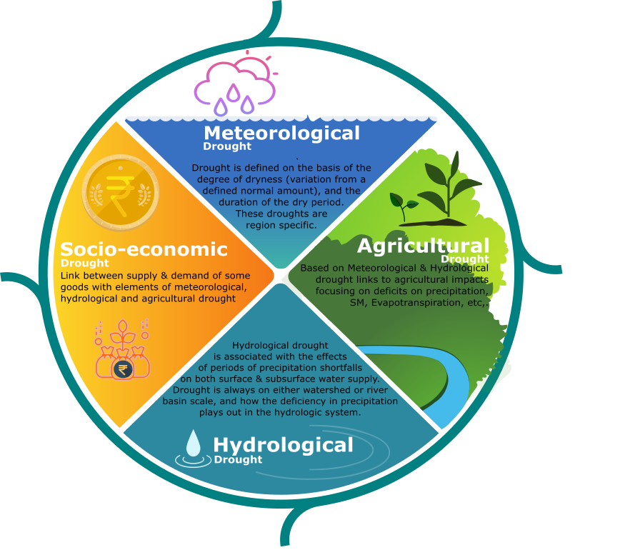

Figure 1: Drought types and their definition

These drought types occur across different time scales (Figure 2) with meteorological drought followed by agricultural, hydrological, and socio-economical drought. Figure 2 gives the time order of the drought along with main indicators and their impact. Each drought type is measured using several indicators (Table 1). These indicators in various degrees are used to characterize the severity, duration, timing, and geographical extent (World Bank, 2019).

Table 1: Different categories of drought and indicators used

|  |  |
| --- | --- |
| Drought category | Indicators used |
| Meteorological drought | Rainfall deficit, Standard Precipitation Index (SPI), dry spells |
| Agricultural drought | Sown area, productivity, Soil moisture adequacy |
| Hydrological drought | Stream flow- discharge, Groundwater Levels, reservoir storage level |
| Socio-economic drought | Food storage, Markets, Supply and demand of agricultural inputs |

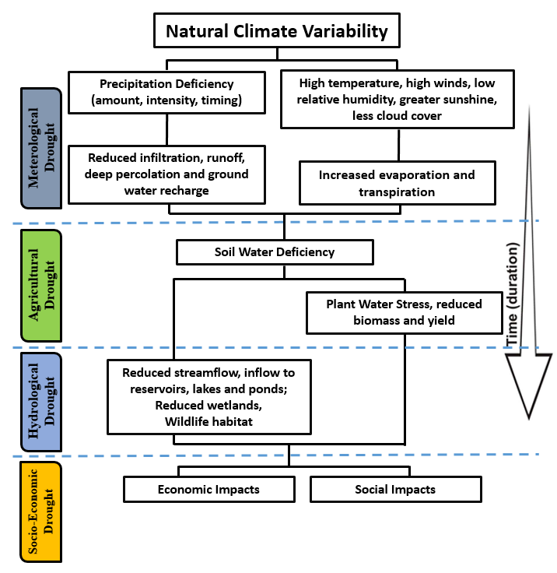

Figure 2: Sequence of drought occurrence and impacts for commonly accepted drought types. Primarily droughts originate from a deficiency of precipitation or meteorological drought with other types of drought and impacts cascade from this deficiency. (Source: National Drought Mitigation Centre (2005), India drought Manual, 2016)

## 2.2 Drought assessment and declaration in India

India manual for drought management (2016) provides a comprehensive overview of different drought types, indicators used, and how the onset of drought is declared. Figure 3 gives the conceptual flow of drought declaration in India. Drought declaration is based on the assessment of multiple indicators at multiple levels. The primary indicator is rainfall which is assessed for deficiency of rainfall and dry spells and acts as a starting trigger of drought. After that, impact indicators across agricultural, remote sensing, soil moisture, and hydrology are evaluated. For the drought to be declared, at least 3 of these 4 impact indicators must be assessed. Based on the assessed indicators, the intensity of drought is based on the following criteria:

1. Severe drought: If all the selected 3 impact indicators are in a severe category.
2. Moderate drought: If two of the selected 3 impact indicators are in Moderate or Severe class
3. Normal: If the impact indicators are all in the Normal class

Considering that irrigation infrastructure and storage can mitigate some of the impacts of drought, there is an option to decrease the drought category if > 75 % area is irrigated. The number of indicators and process itself indicates that drought is a complex process with no single indicator or index that can precisely forecast either the onset or the intensity of drought. Given the complexity of drought hazard and agricultural vulnerability to drought, careful preparation is critical to an effective response and mitigation of drought impacts.

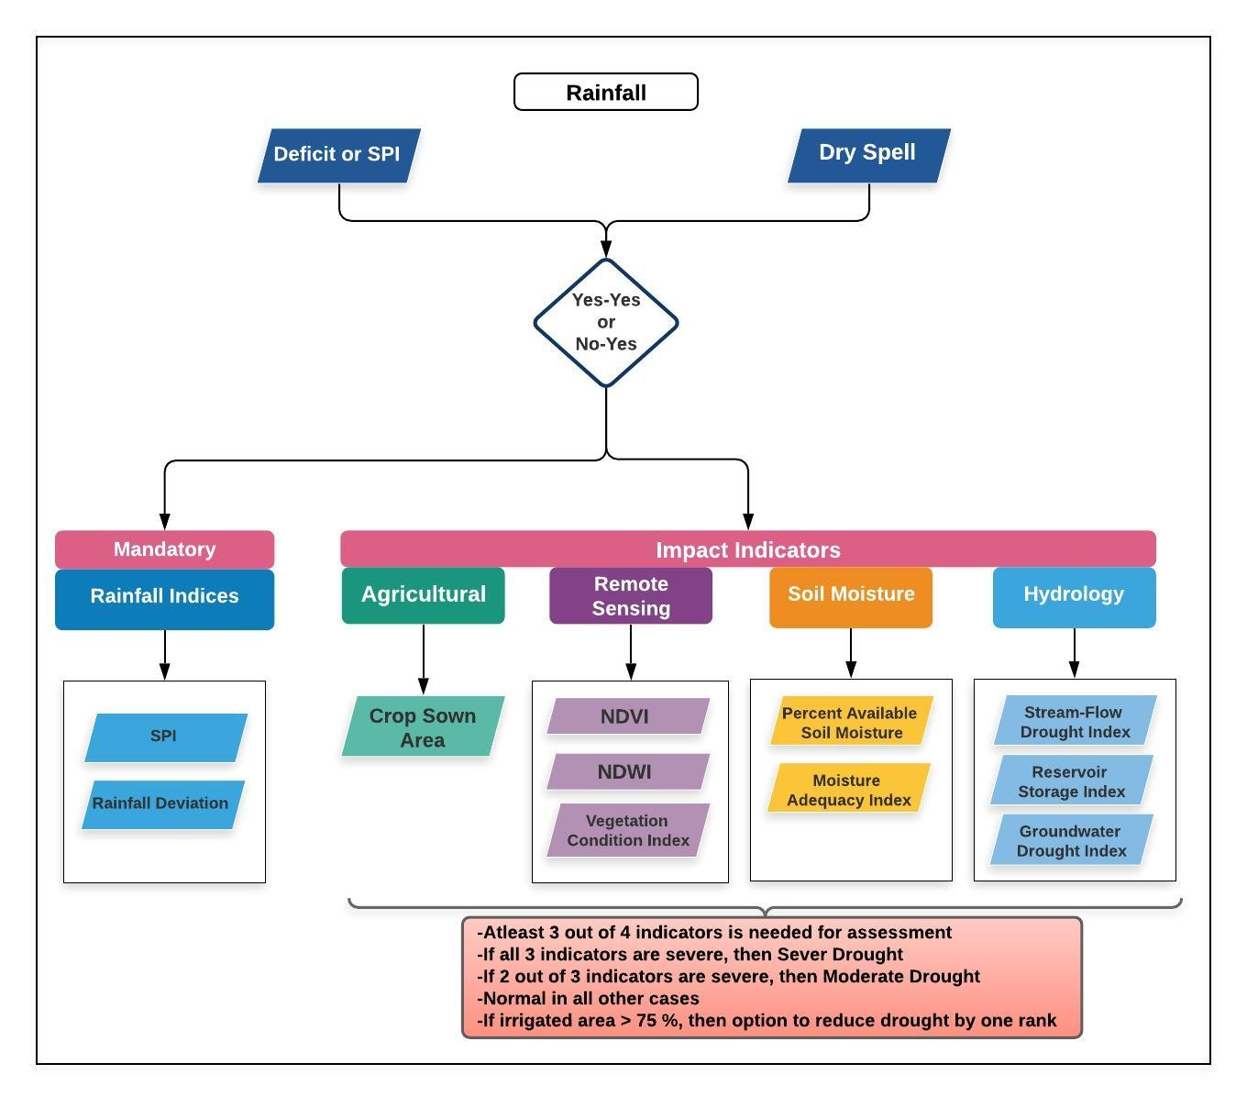

Figure 2: Process of drought declaration (India drought manual, 2016)

# Aim of the Project

India is highly vulnerable to drought primarily caused by temporal and spatial variations of rainfall despite moderate average annual rainfall over the country. In India, about 73% of the total annual rainfall is received in a short window of about 100 days and for over 33% of the cropped area, the average annual rainfall is low (750 mm). Compounding the problem is the limited irrigation coverage which is less than 50% of the country’s net cultivated area, over-exploitation of groundwater and sub-optimum storage capacity, and conservation of surface water leading to inadequate water supply for irrigation (DAC, 2002). To safeguard crop production and livelihoods associated with it, there is a need for drought-proofing agriculture. Thus the key focus of the project is to mitigate impacts of agricultural drought in ITC’s agri-catchments and evolve a framework for drought-proofing of ITC’s agri-catchments. With this aim, based on multiple discussions with ITC colleagues and partners during the project period, four main project tasks were identified:

* + **Defining drought proofing:** As no consistent definition for drought proofing exists, the scope of the task would be to determine the definition of drought proofing of agri-watersheds/catchments.
  + **Classification of drought risk:** Since drought proofing mechanisms will depend on frequencies and intensity of drought risk, this task would focus on assessing ITC Project’s agri-watersheds drought risk. The project will propose a simple methodology for the classification of drought risk.
  + **Drought proofing framework and tool:** This step will involve developing a consistent and integrated framework for assessing *drought proofing* of agri-catchments and prepare a simple and robust tool to operationalize the framework. Such a framework and tool would have to be location-neutral and should be simple enough so that field-based staff dealing with natural resources management (NRM) and NGO personnel, which are trained enough to collect relevant data and input the same into given framework/tool can use the framework.
  + **Recommend interventions:** Once the definition, framework and tool have been developed, this task will apply the framework and tool to identify interventions required to achieve ‘drought proofing’ and for assessing the effectiveness of ongoing activities/interventions in ITC agri-catchments of Prakasam (AP), Mysore (Karnataka), Jhalawar (Rajasthan) and Sehore (Madhya Pradesh) (Figure 4).
  + **Capacity building**: Focus on building the capacity of partners to effectively operationalize the tool for building long and short-term drought proofing plans in ITC’s agri-catchments.

Accordingly, the report has been further outlined in the same order covering the above five tasks.

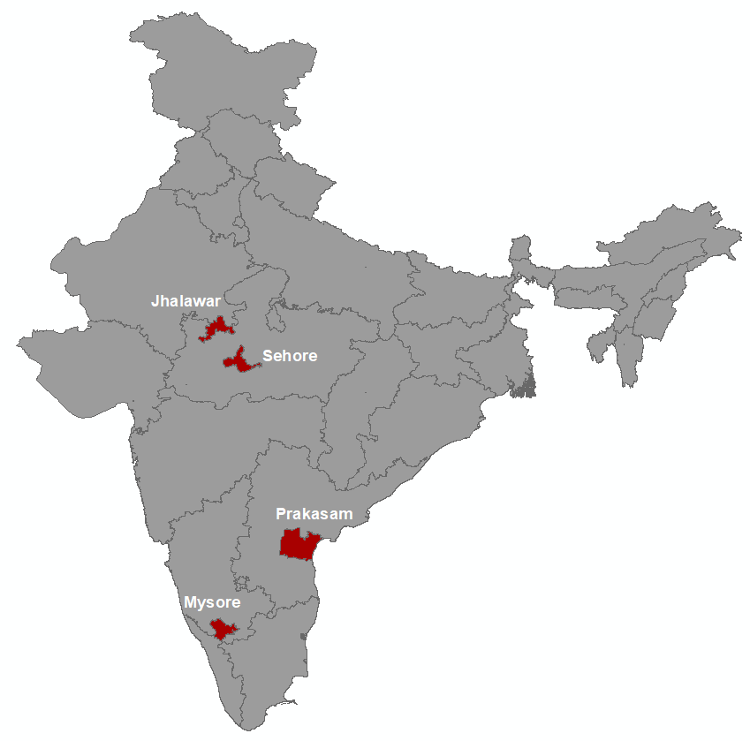

Figure 4: ITC’s Agri-Catchment locations

# Concept of ‘Drought Proofing’

Drought proofing was enunciated as a policy goal for the first time in 1987 and since then there is a welcome shift from traditional ad-hoc reactive response to more pro-active actions and preparedness measures. Drought proofing conceptually means ensuring the capacity to meet the basic material and physical needs of the local population (both human and animal) to have minimal distress during a drought period (Chopra et al., 1995). If an area is ‘drought proofed’, it implies that the local production resource base can provide a certain amount of food, fuel, fodder, drinking water, and livelihood resources during a drought. It is important to note that even with ‘drought proofing’ efforts, the production system during a drought year may operate at a level lower than that of a normal year. Drought-proofing essentially aims at enhancing the availability of water during a drought such that the decrease in production can be limited to an acceptable level. Specifically, in the context of the project and for ITC’s agri- catchments, based on discussions drought proofing is defined as:

*Preparing the catchment to face drought with the minimum possible adverse impacts by efficient and productive use of water resources to stabilize crop production and farm income.*

Thus, in the project, the focus is primarily agricultural drought. Agriculture drought is primarily manifested through soil moisture deficit which leads to wilting of plants and prolonged soil moisture deficit damages the crops due to drought. Drought proofing must, therefore, aim at enhancing soil moisture and water availability during a drought period to minimize production loss. In our definition, drought proofing is aimed at eliminating and/or minimizing crop production losses (from loss of area or loss of yield) in the given watershed. As the focus is stabilizing crop production with agricultural water management practices in a watershed, meeting *crop water requirements* of the given cropping pattern to minimize crop production losses is considered as the key determinant to drought proofing.

Allowable or minimized level of production loss as threshold can be decided by stakeholders to quantify drought proofing. This way drought proofing can be defined relatively i.e. an area is 100 % drought proof when 100 % of crop water requirements are met leading to no production loss for the given cropped area and cropping pattern. The threshold level of drought proofing is contingent upon the objective of stakeholders and is constrained by drought intensity, available biophysical and financial resources. While achieving 100 % drought proofing is ideal, this may or may not be possible under the above constraints and efforts should be to achieve the best feasible level of drought proofing. Increasing farmers resilience (income proofing) would be an outcome of stabilizing crop production.

Our drought proofing framework would focus on the technical assessment of improving water resource availability and water use efficiency. Therefore, drought proofing in the study is assessed as to how different water resource management with supply and demand side interventions can help drought proof crop production. In terms of interventions, special focus would be given to non-engineering solutions such as nature bases solutions (NBSs), forest for water, soil moisture management, sub-surface flow improvement, etc. as part of the watershed interventions. The study would focus on all key crops of the watershed.

# Classification of drought risk

As drought is characterized by the intensity, duration, and geographical extent, the use of different drought indices is accepted as best practice to assess drought risk (World Bank, 2019). Some of the known indices for characterizing drought risk are given in Table 2. A drought index is a standardized numerical value based on anomalies of a selected parameter (e.g. precipitation, soil moisture) when compared with its long-term mean and can be used as an indicator when compared with an agreed categorization (World Bank, 2019). Since the primary causative factor of drought is rainfall, rainfall-related meteorological data is always considered while assessing drought and other indices are evaluated in conjunction with rainfall data. Rainfall based indices are mostly used for characterizing drought risks of the given area.

Table 2: Examples of different types of drought indices

|  |  |
| --- | --- |
| Type | Indices |
| Rainfall based indices | Rainfall deviation, Standardized Precipitation Index (SPI), NDWR (Number of Days Without Rain), etc. |
| Vegetation based indices | NDVI (Normalized Differential Vegetation Index), VCI (Vegetation Condition Index), Area under sowing. |
| Water-Related Indices | GWDI (Ground Water Drought Index), RSI (Reservoir Storage Index), SFDI (Stream-Flow Drought Index), CWDI (Crop Water Development Index), etc. |
| Soil Moisture and evapotranspiration based drought indices | MAI (Moisture Adequacy Index), PASM (Percentage Available Soil Moisture), CMI (Crop Moisture Index), SMA (Soil Moisture Anomaly), etc. |

## 4.1 Standard Precipitation Index (SPI)

A widely used rainfall index is the *Standard Precipitation Index (SPI) (*World Bank, 2019; Sönmez et al., 2005) *and* is recommended to be used to assess ITC agri-catchments risks to drought*.* SPI is calculated by taking the difference of the precipitation from the mean for a particular time step, and then dividing it by the standard deviation and is based on the long-term precipitation data (Sönmez et al., 2005).



SPI has been used widely for assessing drought risk because of its simplicity and implicit advantage. Some of the benefits of using SPI are:

* It assigns a single numeric value to precipitation, which can be compared across regions and time scales with markedly different climates.
* Needs only rainfall data which is the primary causative factor of drought and easy to calculate
* Drought initiation and termination are an implicit part of the index
* Can be calculated for different time steps (1, 3, 6, and 12 months) with shorter periods for agricultural and meteorological drought and longer periods for hydrological drought
* With SPI, drought intensity, magnitude, and duration can be determined, as well as the frequency of drought

SPI is a dimensionless index where negative values indicate drought and positive values wet conditions with range of SPI values categorized across different intensity class (Table 2).

Table 2: SPI values based drought categories

|  |  |
| --- | --- |
| **SPI values** | **Drought category** |
| **0 to -0.99** | Mild drought |
| **-1.00 to -1.49** | Moderate drought |
| **-1.50 to -1.99** | Severe drought |
| **< -2.0** | Extreme drought |

For assessing drought risk of ITC agri-catchments, the use of SPI based on at least the last 30 years' monthly rainfall data is recommended. For the agri-catchments, SPI is to be calculated for the following duration:

* + Annual SPI (12 months): To assess rainfall inter-year variation and annual drought frequency. Longer/annual droughts are important to assess hydrological droughts and their impact on water storages (groundwater and surface water).
  + Seasonal SPI (3 or 4 months): SPI for each main crop growing season to analyze the frequency and magnitude of drought over the crop growing season. Season SPI is important to assess short droughts leading to soil moisture deficits and small storage deficits during the crop growing season.

For each year and season, % of years under different drought categories is to be calculated. Example of the same is shown in Table 3 for a hypothetical region. Results show that mild drought is the most recurring drought in the region occurring every third year. After that, moderate drought has the highest frequency of occurrence and is relatively more in kharif season. The occurrence of severe and extreme droughts in the region is limited. This suggests that drought-proofing activities should actively focus to cover mild and moderate droughts. Based on this assessment, both seasonal and inter-annual, effective planning and designing of interventions to mitigate seasonal and intra-seasonal drought can be done.

**Table 3:** **Drought intensity and their frequency for different periods.** The percentage indicates the percent of total assessed years classified under different drought categories.

|  |  |  |  |
| --- | --- | --- | --- |
|  | **Kharif (Jun-Sep)** | **Rabi (Oct-Feb)** | **Annual** |
| **No drought** | 50% | 55% | 55% |
| **Mild drought** | 32% | 37% | 39% |
| **Moderate drought** | 13% | 5% | 0% |
| **Severe drought** | 3% | 5% | 5% |
| **Extreme drought** | 3% | 0% | 5% |

# Drought proofing framework

Drought-proofing is a continuous process that requires taking water management interventions over both normal and drought years (IHD, 2002). Drought proofing strategyrequires both long- and short-term interventions. Better planning and implementation of water supply augmentation interventions (surface and groundwater) and optimum use of water during normal and/or above normal years provide ample opportunities to build resilience for future drought years to bank upon. Drought-proofing water management interventions include supply-side measures like building storages, recharging groundwater, moisture conservation, and bringing water from outside, and demand-side measures like water management measures for increasing irrigation and on-farm water use efficiency, shifting to low water demanding crops, water budgeting, and crop diversification. Enhanced water storages (in-situ, surface, and groundwater) and efficient water use management interventions are central to comprehensive drought proofing. The selection and implementation of interventions requires a good understanding of water balance and water availability assessment.

To account for water supply and demand dynamics, a water balance based drought proofing framework is conceptualized and developed for designing water management interventions to mitigate the impact of droughts on crop s. Drought proofing in a watershed is conceptualized as an interaction between water availability for crops and water use efficiency (Figure 5). At the base level, drought proofing is defined as an interaction between water availability for a crop (mm or m3 ha-1 or % of crop water needs met) and water use efficiency (Figure 5). Water availability for a crop is the water available from all the sources (rainfall, soil moisture, groundwater, and surface water storage) to meet crop water requirements. Water efficiency determines how efficiently irrigation water is used. For irrigated areas, this is the irrigation application efficiency. For rainfed areas, this can be translated to how efficiently rainfall is used.

Across a simple 2*2 plane, we can identify four distinct quadrants (Figure 5) with water availability for a crop on y-axis and water use efficiency (WUE) on x –axis.

**Quadrant 1:** The top right quadrant is the desired quadrant in which water availability (i.e. for meeting most of crop water needs) and high WUE (i.e. water is used productively) are met. Crops falling in this quadrant require minimum interventions. However, with intra and inter-year variability, there is a need to ascertain this for different seasons and different years. For instance, in a normal year, the crop might lie in quadrant 1 but move to quadrant 4 in a drought year thus needing provision for water supply augmentation.

**Quadrant 2:** The crop falling in the top left quadrant indicates high water availability but moderately less WUE. In this case, interventions are mainly focused on the demand/efficiency improvement i.e. improving WUE. Few examples of such interventions are micro-irrigation, land leveling (increasing efficiency of irrigation water application), mulching (reducing non-beneficial evaporation), etc.

**Quadrant 3:** The crop falling in the bottom left quadrant indicates low water availability and low WUE. In this case, both supply and demand-side interventions are required to drought proof the crop.

**Quadrant 4:** The crop falling in the bottom right quadrant indicates low water availability but high WUE. In this case, interventions are mainly focused on the supply side i.e. improving water availability. Few examples of such interventions are farm ponds, stop/check dams, groundwater infiltration pond, subsurface wells, etc.

Using this conceptual framework, analysis of crops in different years (normal, wet, and drought) can indicate the quadrant in which a crop in a watershed is and which interventions with what intensity are required to safeguard the crop production. This framework can be applied at the watershed level (averaging all crops) and at crop level (individually for rainfed and irrigated or aggregating them) depending upon the objective and case in point.

High crop water availability

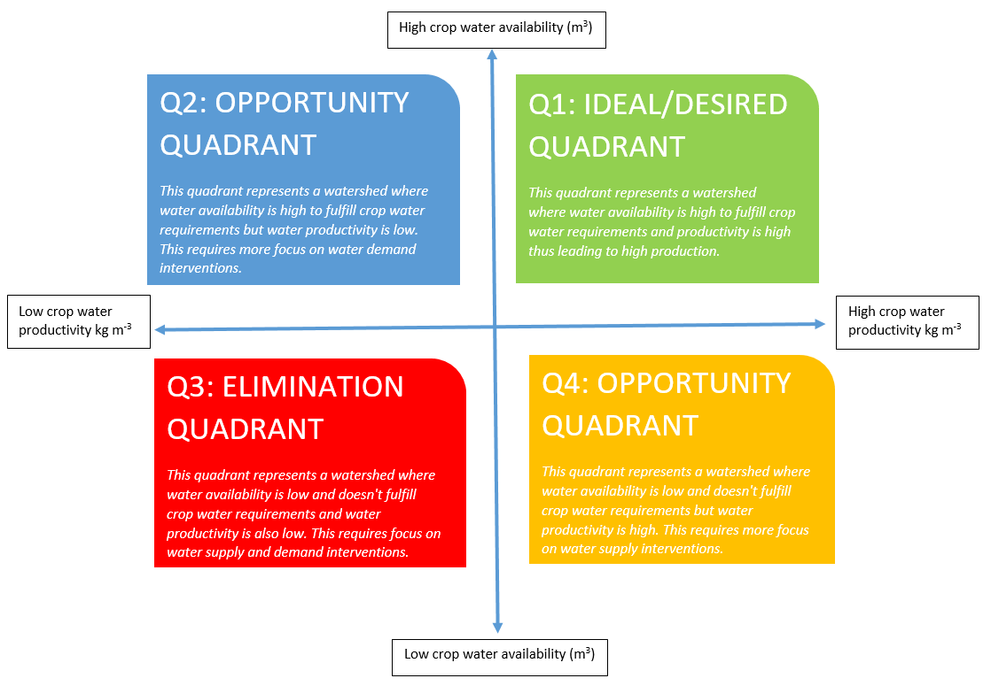

Low water use efficiency

High water use efficiency

Low crop water availability

Figure 5: Conceptual physical drought proofing framework

## 6.1 Drought proofing indicators

The conceptual framework shows that drought proofing is achieved through increasing water availability and water use efficiency. This translates to sufficiently meeting crop water needs which eventually translates to an increase in crop yields and production. Accordingly, drought proofing indicators are classified into primary and secondary indicators (Table 4). Primary indicators represent the status of drought proofing whereas secondary indicators represent the intermediatory factors that are needed to achieve drought proofing. These indicators can be calculated for different scenarios of rainfall (indicating drought severity) with multiple water management scenarios to assess how rainfall deficit impacts production and how effective are different management scenarios in mitigating it.

**Table 4: Drought proofing primary and secondary indicators**

|  |  |  |  |
| --- | --- | --- | --- |
| Type | Indicators | Variable | Interventions |
| Secondary | Increase in water availability | Surface storage capacity | Farm pond, Check dams |
| Groundwater storage | Recharge interventions |
| Soil moisture | Mulching |
| Increase in water use and irrigation efficiency | Area under improved irrigation measures | Micro-irrigation, land leveling |
| Area under water-saving interventions | Direct seeded rice, Alternate wetting and dry (AWD) |
| Primary | Percent of crop water needs met | Actual crop evapo-transpiration (AET) relative to potential ET | - |
| Actual yield as a percent of attainable yielda | Observed crop yield | - |
| Crop Production | Observed crop production relative to potential production | - |

a *Attainable yield is defined as yield achieved when water in not limiting and all other non-water management interventions are in place.*

# Water Balance Tool for operationalizing framework

The drought proofing conceptual framework discussed in the above section requires the assessment of total crop water availability, crop water use efficiency of different crops, and simulating how water management practices can help drought proofing at the watershed scale. With water as the key input to the drought proofing framework (Figure 6), a simple and robust *Water Balance Tool* is developed to operationalize the framework. The two key functions of the tool are:

* To assess the water balance of the study area for various hydrological conditions (dry, normal & wet years)
* To assess the impact of proposed water management interventions in achieving drought proofing

The tool applies a monthly water budget approach in balancing the water resources availability and water demand within the study area and is suitable for homogenous agri-catchments with crop area as dominant land use. The scale of analysis for water balance tool is watershed which is the hydrological unit for water resource development, planning, and management. Appropriate watershed size would be such that the cropping and biophysical characteristics don’t show too much heterogeneity within the watershed. The tool has a simple interface and is modeled in excel spreadsheet with minimum input data requirements for simplifications (Figure 7). The design philosophy is to have a simple tool with limited data required so that the field level NRM staff and NGO personnel, who are trained enough to collect relevant data and input the same into the given framework/tool, should be able to apply it.

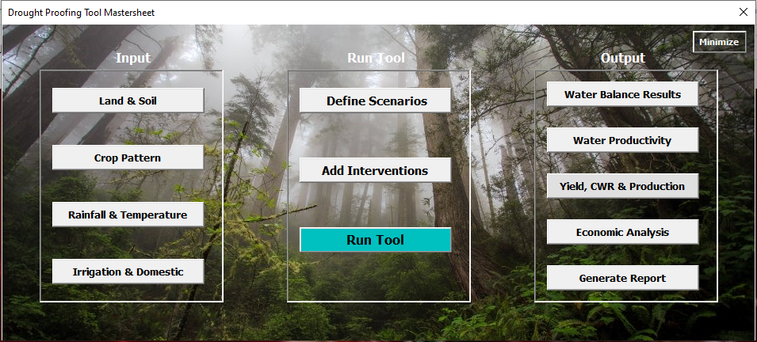

Figure 7: Interface of developed water balance tool

Below we briefly summarize the methodology, key steps, and data requirements of the tool. For details, please check Technical Manual, User Manual, and Case Study example.

## 6.1 **Methodology**

The tool applies a monthly water balance approach in balancing the water availability and water demand within the study area. Figure 8 gives the conceptual methodology of the water balance tool. Input data on climate, land, soil, crops, and irrigation is added. Thereafter, water balance is calculated consisting of water availability and demand. Water availability components of effective precipitation, surface runoff, evapotranspiration, soil moisture, and groundwater recharge are estimated. Water demand consists of crop water and domestic water requirements. Domestic water demand is met first through surface and groundwater storages. Thereafter, crop water demands (CWD) are met. For rainfed area, CWD is met only through effective rainfall and soil moisture storage. For irrigated areas, CWD is met through effective rainfall, soil moisture storage, and irrigation storage (surface and groundwater). Water storage is updated monthly and availabilyt of water in storage limits the irrigation abstraction to meet water requirements. In case all crop water requirement is met, yield is equal to attainable yield and in case it is not met, yield is calculated using FAO Yield response factor (Steduto et al., 2012) which calculates yield based on how much of crop water need is met (for details see technical manual).

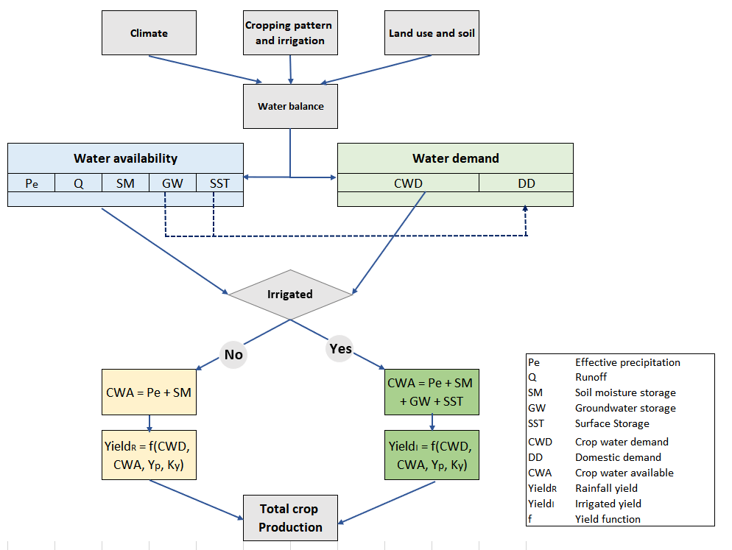

Figure 8: Process flow of water balance tool

Figure 9 shows schematic representation of the water balance component of the tool and Table 4 presents a brief methodology used to calculate these components. Details and equations are given in the attached technical manual. Precipitation is first partitioned into overland runoff (QO). Thereafter, effective precipitation (P-QO) infiltrates and increases soil moisture storage (SMST). Soil moisture storage (SMST) maximum water holding capacity is limited by soil field capacity. Soil moisture is depleted through evapotranspiration (ET). ET is constrained by soil moisture deficit (SMD) which is the difference between maximum water holding capacity and avialable soil moisture storage (SMST). Any surplus storage above soil maximum water holding capacity is assumed to be natural groundwater recharge (GWNR) adding to aquifer storage (AQST). In case water storage interventions are in place, overland runoff (QO) can be captured by surface water storages (SWST) and built groundwater recharge structures capacity (GWST). Irrigation from surface water (ISW) and groundwater (IGW) reduces surface and groundwater storage and adds to evapotranspiration (ETSW and ETGW). In addition, open surface evaporation from surface water storage also adds to ETSW.

Overland runoff (QO) after captured by surface and groundwater recharge structures leaves the watershed (Q). Infiltration from surface storages (INSW) and artificial recharge (GWAR) from recharge structures add to aquifer storage (AQST). Maximum storage of aquifer is limited by aquifer depth and specific yield. At the end of the day, any surplus aquifer storage above maximum storage of aquifer is converted to rejected recharge (GWRR) and added to runoff (Q) leaving the watershed. Overall daily water balance is given by (Eq. 1):

|  |  |
| --- | --- |
|  | *Eq. 1* |

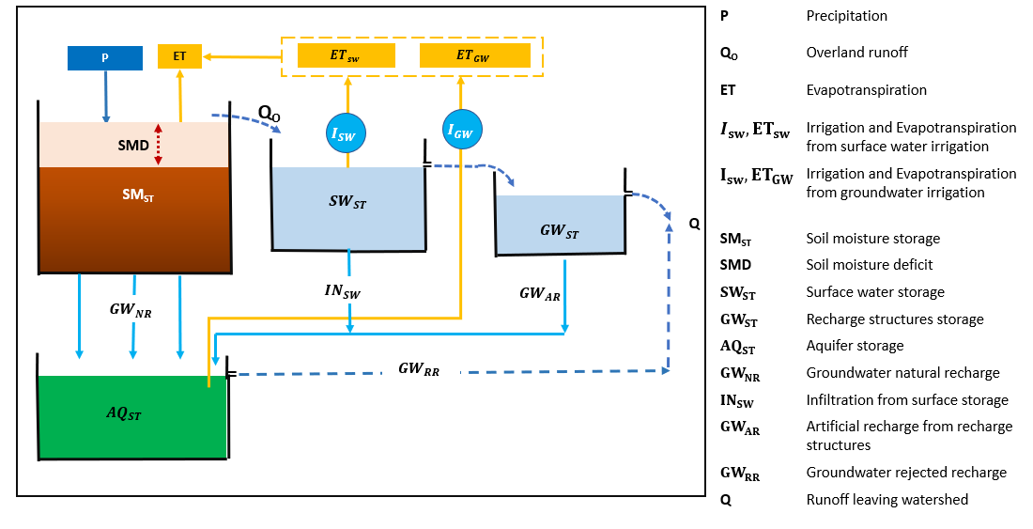Where, – Precipitation, ET – Evapotranspiration, – Soil moisture storage, – Runoff leaving watershed, aquifer storage and Surface water Storage

**Figure 9: Conceptual water flows in water balance tool**

Table 4: Brief description of water balance components and how they are modelled in the tool

|  |  |  |
| --- | --- | --- |
| Water balance component | Process | Source/link |
| Runoff | SCS-curve number method. Runoff depends on land use and rainfall. | [USDA, 1986](https://www.nrcs.usda.gov/Internet/FSE_DOCUMENTS/stelprdb1044171.pdf) |
| Crop water requirement | Potential ET is calculated (Hargreaves equation) and combined with crop coefficient approach to get crop water requirement | [FAO, Paper-56](http://www.fao.org/3/X0490E/x0490e0a.htm#TopOfPage), [Hargreaves & Samani, 1985](http://dx.doi.org/10.13031/2013.26773) |
| Soil Moisture storage | Soil moisture is depleted from crop and soil evaporation. | [Ruston et al. 2005](https://doi.org/10.1016/j.jhydrol.2005.06.022) |
| Crop yield | FAO yield response factor | [FAO, Ky function](http://www.fao.org/3/i2800e/i2800e02.pdf)  [FAO, Paper-66](http://www.fao.org/3/i2800e/i2800e00.htm) |

### 6.2 Water management interventions

Water management practices are inbuilt in the tool. They impact both the water availability (by building water storages) and demand (by changing water application efficiency). Water management practices are categorized under supply, demand, and soil & moisture practices (Figure 9). Supply practices build the storage that can be used for irrigation, demand management interventions focus on redcuing demand via increasing the irrigation water application efficiency and soil & moisture practices enhance soil moisture storage, increase recharge and reduce non-beneficial soil evaporation. Detailed methodology of how they interact in the tool is given in the technical manual.

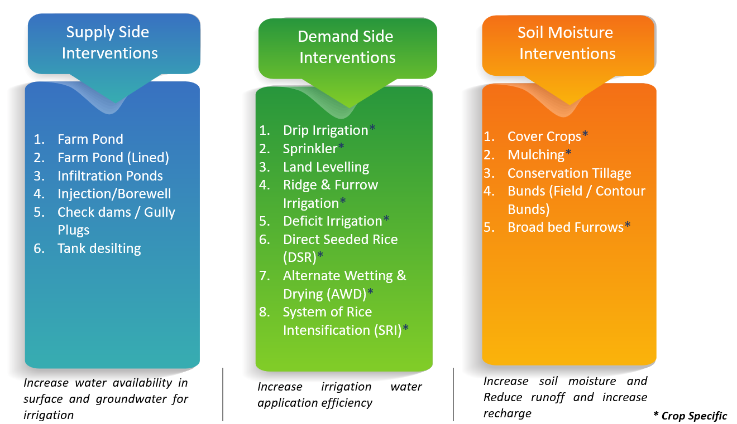

Figure 8: Category of water management practices inbuilt in tool and their impact

6.3 **Running the tool**

There are 5 main steps involved in running the tool (Figure 9):

* Step1: Input data is entered in the tool.
* Step 2: Baseline scenario is simulated. Baseline scenario has no water management interventions in place.
* Step 3: Water balance, crop water requirements, and crop water deficit results are analyzed under baseline scenario.
* Step 4: Based on these results, water management interventions are planned and entered into the tool as scenarios.
* Step 5: Scenarios are simulated and their impact on drought proofing analyzed. If drought proofing is not realised, steps 3 and 4 are repeated until the best possible results on drought proofing are obtained.

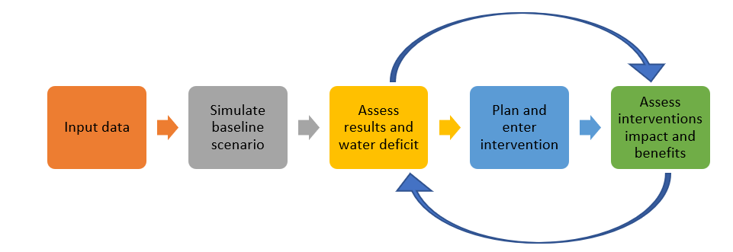

**Figure 9: Conceptual workflow of applying drought proofing tool**

Detailed steps to prepare input data and run the tool are provided in the user manual. Figure 10 describes the overall structure of tool, input data requirements, and results.

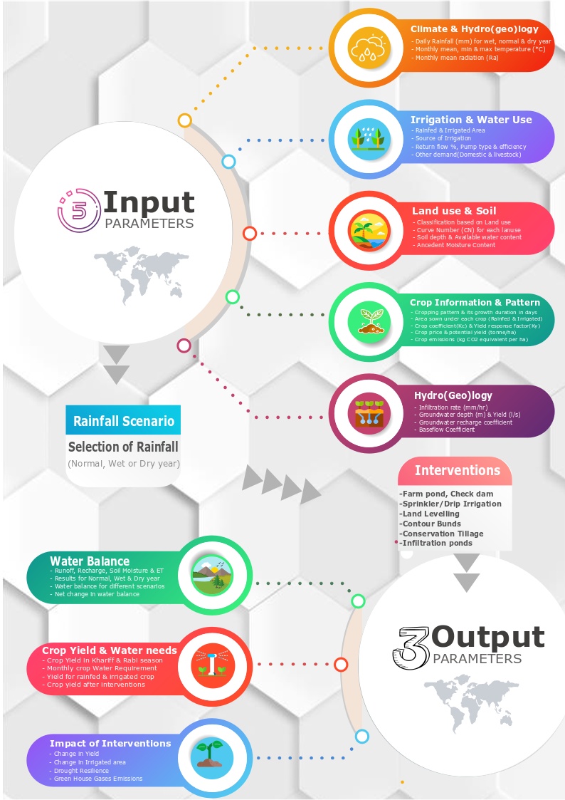

# Application of tool to ITC-Agri catchments

The water balance tool was applied in four agri-catchments located in Prakasam (AP), Mysore (Karnataka), Jhalawar (Rajasthan), and Sehore (Madhya Pradesh) (Figure 4). Table 5 gives a brief description of agricultural catchments. A detailed description of each watershed and results can be accessed in reports of each watershed here. We provide here the summary results of each study.

Jhalapratan and Kulans catchment are situated in the northern part of the country primarily receiving their rainfall during the southwest monsoon (Jun-Sep). In these watersheds, more than 90 % of rainfall is received during the southwest monsoon months of June-Sep. Ravanduru and Cherukuru are in the southern part of the country receiving rainfall from both southwest (Jun-Sep) and northeast monsoon (Oct-Dec). All watersheds are intensively cultivated with agricultural area covering 70-95% of the watershed total area. Also, cropping intensity is high in all watersheds except the Cherukuru watershed in Prakasam.



*Table 5: Summary characteristics of agri-watersheds*

|  |  |  |  |  |  |  |
| --- | --- | --- | --- | --- | --- | --- |
| Watershed | District, State | Area (ha) | Agricultural area (%) | Average Rainfall (mm) | Cropping intensity | Soil |
| Jhalarapatan | Jhalawar, Rajasthan | 7663 | 71 % | 934 | 183% | Clay loam |
| Ravanduru | Mysore, Karanataka | 2285 | 82 % | 842 | 199% | Clay Loam |
| Cherukuru | Prakasam,  Andhra Pradesh | 6727 | 70% | 869 | 100% | Clay and clay loam |
| Kulans | Sehore,  Madhya Pradesh | 4328 | 94 % | 905 | 199% | Black cotton |

Study watersheds show a wide spectrum of cropping patterns. Jhalarapatan and Kulans watersheds have two distinct crop growing seasons: kharif (overlapping monsoon season) and rabi (post-monsoon season). In both watersheds, soyabean and maize are the main crops in the kharif season whereas wheat is the main crop in the rabi season. In these watersheds, kharif crops are primarily taken as irrigated crops whereas rabi crop completely relies on irrigation.

For Cherukuru watershed in Prakasam, major crop grown in the watershed is Tobacco, followed by long-duration crop of Chilly. Tobacco is sown near the end of southwest monsoon in September. Chilly is sown in August and taken as long duration crop (210 days). Short duration Bengal gram (60 days) is taken during northeast monsoon. Tobacco and Bengal gram are primarily taken as rainfed crops with provision for supplemental irrigation. Chilly is completely irrigated. Other than there are Eucalyptus plantation and small areas under horticulture crops (papaya, guava).

For the Ravanduru watershed in Mysore, there are two main cropping seasons in the watershed: Kharif (overlapping monsoon season, May to Sep) and Rabi (post-monsoon season). In the kharif season, the major crop grown is Tobacco, followed by a small cultivated area of Ginger and Red Gram. Tobacco crop is primarily rainfed but equipped for supplemental irrigation. In the rabi, major crops grown are Ragi followed by a relatively small cultivated area of Cowpea, Maize and Paddy. Rabi crops (post-monsoon season) are completely rainfed, relying on northeast monsoon rainfall (Oct to Dec). Supported by well-distributed rainfall in Kharif and Rabi season, cropping intensity is high (~ 199 %) in the watershed.

*Table 6: Summary characteristics of cropping pattern and irrigation for agri-watersheds*

|  |  |  |  |  |
| --- | --- | --- | --- | --- |
| Watershed | Kharif | | *Rabi* | |
| *Crop* | *Irrigation* | *Crop* | *Irrigation coverage* |
| Jhalarapatan | Soyabean, Maize, Blackgram | *Supplemental irrigation* | Wheat and Mustard | *100 %* |
| Ravanduru | Tobacco | *Rainfed, small area under supplemental irrigation* | Ragi | *rainfed* |
| Cherukuru | Tobacco, Red gram, Chilly | *Chilly is 100 % irrigated* | Bengal gram | *Rainfed* |
| Kulans | Soyabean, Maize | *Rainfed* | Wheat | *100 %* |

## ***8.1*** Drought risk

Table 7 summarizes the drought risk analysis for each watershed assessed using *Standard Precipitation Index (SPI) (*World Bank, 2019; Sönmez et al., 2005, section 4). Drought risk assessment using SPI is calculated based on monthly rainfall data of the last 38 years (1980-2017). To segregate seasonal and annual drought, drought frequency for the annual, kharif, and rabi season is calculated separately. Shorter periods (seasonal droughts) are important to assess agricultural droughts whereas longer/annual droughts are used to assess hydrological droughts. Based on an assessment of seasonal and annual droughts, effective planning and designing of interventions to mitigate drought can be done.

For Jhlarapatan, results show that mild drought is the most occurring drought in the region occurring every third year. Moderate drought has the highest frequency of occurrence relatively more in kharif season. The occurrence of severe and extreme drought in the region is limited. Annual time series of rainfall with drought category (figure 3 in the detailed watershed report ) shows that of last 15 years, 10 years have been either mild or moderate drought year.

For Sehore, results show that mild drought is the most occurring drought in the regions occurring almost every third year. After that, moderate drought has the highest frequency of occurring relatively more in the rabi season. The occurrence of moderate and severe drought is relatively low as compared to mild droughts. Annual time series of rainfall with drought category (figure 3 in the detailed watershed report) shows that of last 15 years, 8 years have been mild drought year.

For Mysore, results show that mild drought is the most occurring drought in the regions occurring every third year. After that, moderate drought has the highest frequency of occurring relatively more in the rabi season. The occurrence of severe drought is relatively high in kharif season whereas the occurrence of extreme droughts in the region is limited. Annual time series of rainfall with drought category (figure 3 in the detailed watershed report) shows that of last 15 years, 5 years have been moderate drought year whereas 3 years have been mild drought.

For Prakasam, more than 50 % of the years, there is no drought. Results show that mild drought is the most occurring drought in the regions occurring every third year for both southwest and northeast monsoon seasons. After that, moderate drought has the highest frequency of occurring, but the relative frequency is low as compared to mild drought. The occurrence of severe and extreme drought is very limited. Annual drought occurrence is different showing the impact of calculating drought risk frequency for different periods. Annually mild, moderate, and severe droughts occur more or less at the same frequency. Annual time series of rainfall with drought category (figure 3 in the detailed watershed report) shows that though most years have been normal, drought keeps recurring frequently. The last 3 years have seen 2 severe and 1 moderate drought.

Results show that in all the watersheds mild drought has the highest frequency followed by moderate drought intensity. This suggests that drought proofing activities should actively focus to address mild and moderate droughts.

*Table 7:* **Drought intensity and frequency in agri-watersheds.** The percentage indicates the percent of total assessed years classified under different drought categories.

|  |  |  |  |  |  |
| --- | --- | --- | --- | --- | --- |
|  | *Drought category* | Jhalarapatan | *Ravaduru* | *Cherukuru* | *Kulans* |
| *Annual* | **No drought** | 55% | 53% | 61% | 53% |
|  | **Mild drought** | 39% | 24% | 18% | 34% |
|  | **Moderate drought** | 0% | 21% | 11% | 5% |
|  | **Severe drought** | 5% | 3% | 11% | 5% |
|  | **Extreme drought** | 5% | 0% | 0% | 3% |
|  |  |  |  |  |  |
| *Kharif* | **No drought** | 50% | 53% | 53% | 50% |
|  | **Mild drought** | 32% | 32% | 37% | 34% |
|  | **Moderate drought** | 13% | 5% | 8% | 8% |
|  | **Severe drought** | 3% | 11% | 0% | 8% |
|  | **Extreme drought** | 3% | 0% | 3% | 0% |
|  |  |  |  |  |  |
| *Rabi* | **No drought** | 55% | 53% | 50% | 61% |
|  | **Mild drought** | 37% | 32% | 34% | 24% |
|  | **Moderate drought** | 5% | 11% | 11% | 8% |
|  | **Severe drought** | 5% | 3% | 3% | 5% |
|  | **Extreme drought** | 0% | 3% | 3% | 3% |

## 8.2 Summary of results

Table 8 provides the summary of main risks and issues as identified for each watershed based on simulation of drought proofing tool. Detailed simulation results can be assessed in the detailed reports. For both Jhalarapatan and Kulans where more than 90 % rainfall is received during southwest monsoon months (Jun-Sep) impact of drought is severely felt during the rabi season crop. Impact on kharif crops is limited showing low rainfall with supplemental irrigation is sufficient to meet crop water requirements.

For Ravanduru and Cherukuru, the impact of drought is primarily felt for rainfed Tobacco crops. Results show that with supplemental irrigation, the impact of drought can be largely mitigated. In both cases, rabi crops (overlapping northeast monsoon) are taken as rainfed crops and are more resilient to droughts due to their low crop water requirements. In both watersheds, results call for planning and implementing interventions in the southwest monsoon season to build supplement irrigation for rainfed Tobacco crops.

Table 8: Summary of main risks and issues under baseline conditions (based on drought proofing tool results)

|  |  |  |
| --- | --- | --- |
|  | *Kharif* | *Rabi* |
| Jhalarapatan | As most of the kharif area is under supplemental irrigation, the impact of both mild and moderate drought on kharif crop is limited due to concentration of rainfall during monsoon season, crop water requirement met for the irrigated cropped area is ~ 90 % whereas there is a slight decrease in crop water requirement met for rainfed areas ranging from 77-90 %. | During rabi, low rainfall leads to low recharge. As the rabi crop completely relies on groundwater irrigation, the impact of a drought year is visible for wheat. Only 40-50 % of crop water requirements could be met reducing yield significantly. |
| Kulans | For kharif crops, the impact of mild and moderate drought years is limited. More than > 80 % of the crop water requirements are met even in drought years. This reflects that kharif crops in the catchment are already drought proof to an extent for recurring mild and moderate drought years. | Wheat is severely impacted in both mild and moderate drought years. Even in normal years with high rainfall and recharge, results show that only 60 % of wheat CWR can be met. This reflects that current groundwater storage in the catchment is not sufficient to meet the high irrigation requirement of wheat. This is further aggravated in drought years where low rainfall leads to low recharge. In mild and moderate drought years, more than 60 % of crop water requirements (CWR) remains unmet. |
| Ravanduru | Results show that the impact of mild drought remains limited with ~ 80 % of crop water requirement met by rainfall for all crops. The main impact is visible in moderate drought years where low rainfall (566.7 mm) is not sufficient to meet crop water requirements. Only 60 % of Tobacco CWR can be met significantly impacting its yield. CWR met ranges from 58-62 % for Tobacco. However, results show that if Tobacco is provided supplemental irrigation, the impact of drought can be mitigated. | Ragi is taken primarily as a rainfed crop. Ragi has low CWR and is more resilient to droughts. Results show that the impact of mild drought on crop remains limited with ~ 80 % of crop water requirement met by rainfall. Even in moderate drought years, 70-75% of attainable yield is achieved for ragi. |
| Cherukuru | Results show that in both mild and moderate drought years, the impact on irrigated crops (Chilly and partial Tobacco area) is limited. For both irrigated crops, more than 80 % of crop water requirements are met. This reflects that irrigation storage is sufficient to meet much of the irrigation demand of crops.  However, for rainfed Tobacco, CWR met decreases from 80 % in normal years to 64 % in moderate drought years. This reflects the need for building supplemental irrigation facilities for Tobacco in conjunction with developing supply measures to support irrigation. | Results show that Bengal gram with low crop water requirement (CWR) doesn’t get impacted in both mild and moderate drought years despite being rainfed. Even in moderate drought years, up to 80 % of CWR is met. Since Bengal gram is a short duration crop (60 days) with very low CWR which can be met by rainfall and soil moisture. |

## 8.2.1 Recommended interventions

Overview of suggested interventions for drought proofing agri-watersheds is given in Table 10. For a detailed description of interventions and rationale for the same, please refer to the detailed report of each watershed. Recommended interventions are a mix of structural and non-structural interventions. Structural interventions include storage and recharge interventions to enhance storage, providing supplemental irrigation, and improving irrigation efficiency. However, structural interventions are not enough to drought proof agri-watersheds especially those where runoff is limited or not enough to meet the deficit in drought years. Thus, these non-structural interventions including smart irrigation, deficit irrigation, and shifting to low water consuming crops are recommended.

For both Jhalarapatan and Kulans, recommended interventions are similar as both watersheds face similar risks (Table 9). In both watersheds, the rabi wheat crop is severely impacted. Thus, recommended interventions include supply interventions on building surface water storages and groundwater recharge to capture runoff during monsoon season. This is combined with demand side interventions which include enhancing the irrigation water application efficiency. In Jhalarapatan, in addition to structural interventions, non-structural interventions of irrigation budgeting/deficit irrigation in kharif season and shifting some area of wheat to mustard is also recommended. This is necessary to mitigate drought impact on the wheat crop which has higher irrigation water requirements.

For Ravanduru, a mix of structural interventions and non-structural interventions is recommended. Recommended interventions include building supplemental irrigation for Tobacco, on-farm water storage, and efficient irrigation through drip irrigation. In addition, the non-structural intervention of shifting some of the rainfed Tobacco to low water consuming red gram is suggested. For Cherukuru, recommended interventions include building supplemental irrigation for Tobacco, on-farm water storage, and efficient irrigation through drip for chilly. Additionally, mulching is carried out to preserve soil moisture and reduce non-beneficial evaporation.

Table 10: Summary of interventions recommended and designed for drought proofing agri-watersheds

|  |  |  |
| --- | --- | --- |
|  | *Supply* | *Demand* |
| Jhalarapatan | Supply side is proposed to be augmented through storage and recharge from farm ponds, check dams, and infiltration basins. | For the demand side, sprinkler irrigation for rabi crops (mustard and wheat) is planned. Sprinkler irrigation can improve the efficiency of irrigation. In addition, broad bed furrow (BBF) for soyabean is planned. BBF can conserve 15-30 % of water relative to the conventional flat method of sowing and helps in retaining soil moisture (decreasing runoff) and draining excess runoff.  Demand is further to be managed by shifting area from high water consuming wheat to low water consuming crop of mustard  Irrigation budgeting/deficit irrigation: Reduce and/or rationalize irrigation in kharif area so that irrigation storage can be maintained for rabi season. |
| Kulans | Supply side is proposed to be augmented through storage and recharge from farm ponds, stop dams and recharge shafts. | For the demand side, sprinkler irrigation for wheat is planned. Sprinkler irrigation can improve the efficiency of irrigation. |
| Ravanduru | Supplemental irrigation for Tobacco and capturing additional available water through on-farm water storage. | Drip irrigation for efficient application of irrigation.  Shifting Tobacco cultivated area to rainfed red gram (long duration 180 days) which has lower water requirement and its requirement are distributed thus can utilize long-duration rainfall in the watershed much better. |
| Cherukuru | Supply side is proposed to be augmented through storage and recharge from farm ponds and check dams along with developing supplemental irrigation for Tobacco. | For the demand management, drip irrigation for chilly is planned. Drip irrigation can improve the efficiency of irrigation to 90%.  Mulching is carried out to preserve soil moisture and reduce non-beneficial evaporation. |

## *8.2.2* Summary of results

Results of applied interventions are shown in Figure 11. Figure 11 shows the overall watershed drought proofing (in %). Percent drought proofing represents total crop production of the watershed as a percent of total potential crop production (i.e. production without any water stress). Only the baseline and last scenario (a best case scenario in terms of drought proofing and where the intensity of interventions is highest) is shown. For a detailed description of each scenario and the simulated result of each, please refer to the detailed report of each watershed.

For Jhalarapatan, results show that for moderate and mild drought years up to 90 % of drought proofing can be achieved as compared to ~ 70 % in baseline scenarios. This shows that the recommended interventions are sufficient in successfully drought proofing watershed. Additionally, the cost and benefit analysis (see detailed report) shows that all scenarios have benefit-cost ratio > 1.5, suggesting that the incremental benefits under given scenarios are more than the investments for all the scenarios.

For Kulans, results show that for mild and moderate drought years up to 78 % and 70 % of drought proofing can be achieved as compared to 65% and 60 % in baseline scenarios, respectively. Though drought proofing is much higher than baseline conditions but it remains below the Jhalarapatan case where drought proofing percentage is very high (90%). This shows that the recommended interventions are working but are not still sufficient to successfully drought proof watershed. The reason is that even in the best-case scenario, wheat remains vulnerable to drought. *Therefore, there is a need for* additional interventions. One potential non-structural intervention could be to shift crop area from high water-consuming wheat to low water-consuming crops like pulses or coarse cereals or mustard. This will limit the irrigation demand of wheat which is currently very high and surpasses the available irrigation water. However, for all scenarios, benefit-cost ratio (BCR) is close to 1.5 suggesting benefits over 20 years will return 1.5 times the invested amount.

For Ravanduru, results show that for moderate drought years 79 % of drought proofing can be achieved as compared to 70 % in baseline scenarios. Only moderate drought year was analyzed as mild years showed high drought proofing even in the baseline scenario. The range and intensity of interventions were limited by very low runoff in the watershed in moderate drought years. Thus, for Ravanduru there is low potential to further increase the drought proofing percent unless there is the introduction of other low water consuming crops in place of Tobacco or there is water transfer from outside the catchment.

For Cherukuru, results show that for mild and moderate drought years up to 90% of drought proofing can be achieved as compared to 86 and 81 % in baseline scenarios, respectively. Result show that even baseline conditions are good in Cherukuru watershed and recommended interventions can make them better. Cost and benefit analysis (check detailed report) show that all scenarios have BCR ~ 2, suggesting the incremental benefits under scenarios are more than the investments.

Figure 11: Drought proofing (%) for agri-watersheds for mild and moderate years under baseline and recommended scenario

# Capacity building

One of the key aim of the drought proofing framework and tool was to develop the capacity of ITC’s state teams and key NGO partners to apply the tool in field. To enable this, multiple workshops and meetings were held during the entire duration of the project. Table 11 gives the list of meetings and workshops. To start with, an annual workshop on drought proofing was organized to disseminate the framework and tool developed by IWMI to the ITC’s state teams and key NGO partners. The workshop took place on 7th and 8th September 2020. Following the workshop, multiple one-to-one sessions with all the ITC’s state teams and NGO partners working on drought proofing were conducted. Discussion with state teams focused on the more detailed presentation of tool’s capabilities, how it is to be used, and clearing doubts that the state team faced while running the tool.

**Table 11: Schedule for workshop and one to one sessions**

|  |  |  |  |
| --- | --- | --- | --- |
| Date | State | Type | Remark |
| 07/09/2020 | All Teams | Drought Workshop | Annual Workshop – Day 1 |
| 08/09/2020 | All Teams | Drought Workshop | Annual Workshop – Day 2 |
| 17/09/2020 | Prakasam, AP | One to One session | A detailed presentation on drought tool capabilities and demo run |
| 17/09/2020 | Mysore, KA | One to One session |
| 18/09/2020 | Sehore, MP | One to One session |
| 18/09/2020 | Jhalwar, RJ | One to One session |
| 11/12/2020 | Sehore, MP | 1st One to One session | Three sessions with each state team to train the users on running the drought tool, prepare input data requirements and interpret the results. State team and NGO partners got hands-on experience during first two sessions and presented the results during their 3rd session |
| 15/12/2020 | 2nd One to One session |
| 23/12/2020 | 3rd One to One session |
| 22/01/2021 | Mysore, KA | 1st One to One session |
| 27/01/2021 | 2nd One to One session |
| 24/02/2021 | 3rd One to One session |
| 01/02/2021 | Prakasam, AP | 1st One to One session |
| 25/02/2021 | 2nd One to One session |
| 16/03/2021 | 3rd One to One session |
| 16/02/2021 | Jhalwar, RJ | 1st One to One session |
| 01/03/2021 | 2nd One to One session |
| 12/03/2021 | 3rd One to One session |

# References

1. EMDAT, 2019.: Website: <https://www.emdat.be/>. The International Disaster Database, Disaster Trends. Accessed on 01/10/2019
2. NDMC, 2005: *Website.* <https://drought.unl.edu/Education/DroughtIn-depth/TypesofDrought.aspx> Accessed on 01/10/2019
3. Chopra, Ravi; Ravindra, A and Das, Salil. 1995: Drought Proofing Palamu, People’s Science Institute, Dehra Dun. <http://planningcommission.nic.in/reports/sereport/ser/water_policy/3_intro.pdf> Accessed on 01/10/2019
4. Department of Agriculture and Cooperation (DAC), Government of India. 2004: Drought 2002: A Report, Department of Agriculture and Cooperation, Ministry of Agriculture, New Delhi. <https://nidm.gov.in/PDF/manuals/Drought_Manual.pdf>. Accessed: 01/10/2019
5. Department of Agriculture, Cooperation & Farmers Welfare (DAC&FW), 2016. Manual for Drought Management. Ministry of Agriculture & Farmers Welfare, Government of India, New Delhi
6. Institute of Human Development (IHD), 2002: Water Policy for Drought Proofing Chhattisgarh, sponsored by the Planning Commission, New Delhi. <http://planningcommission.nic.in/reports/sereport/ser/water_policy/sty_wtrpolicy.htm>. Accessed: 01/10/2019
7. Mall RK, Singh R, Gupta A, Srinivasan G, Rathore LS. 2006. Impact of climate change on Indian agriculture: a review. *Climatic Change* **78**(2–4): 445–478.
8. Palmer, WC, 1965: Meteorological drought. U.S. Research Paper No. 45. US Weather Bureau, Washington, DC. https://www.ncdc.noaa.gov/temp-and-precip/drought/docs/palmer.pdf .Accessed on 01/10/2019
9. Rushton, K.R., Eilers, V.H.M., Carter, R.C., 2006. Improved soil moisture balance methodology for recharge estimation. Journal of Hydrology 318, 379–399. <https://doi.org/10.1016/j.jhydrol.2005.06.022>
10. Sönmez, F.Kemal., Kömüscü, A.Ü., Erkan, A., Turgu, E., 2005. An Analysis of Spatial and Temporal Dimension of Drought Vulnerability in Turkey Using the Standardized Precipitation Index. Natural Hazards 35, 243–264. <https://doi.org/10.1007/s11069-004-5704-7>
11. Steduto P, Hsiao TC, Fereres E, Raes D. 2012. Crop Yield Response toWater. Food and Agriculture Organization of the United Nations: Rome, Italy.
12. WMO and GWP, 2016. Handbook of Drought Indicators and Indices. Link: <https://www.drought.gov/drought/sites/drought.gov.drought/files/GWP_Handbook_of_Drought_Indicators_and_Indices_2016.pdf>
13. World Bank, 2019. Assessing Drought Hazard and Risk: Principles and Implementation Guidance. Washington, DC: World Bank. Link: <https://www.droughtmanagement.info/literature/WBG_Assessing_drought_hazard_and_risk.pdf>